School of Computing Science

2017-2018

Student: Hasan A.H.J.A.

Mark Student No.: 150454388

Degree Prog.: G400 Stage 3

Module: CSC3095

Exercise: Project Proposal

Due: 23:59:59 Friday, 1st Dec 2017

# Motivation and rationale

Design Space Exploration is a data analysis tool that uses systematic alteration of parameters Gries, Matthias (2004, p. 134). This tool is useful for exploring the designs of heterogenous and complex systems Gries, Matthias (2004, p. 133) like Cyber Physical Systems, which are formed from diverse physical (continuous) and cyber (discrete) components connected by heterogenous networks Al-Hammouri, A.T. (2012, p. 8).

However, design space exploration can become difficult to manage due to the overwhelming nature of design space exploration size Kokhazadeh, A. & Fatemi, O. (2011, P. 550). This presents a challenge to illustrate and interpret this process and it’s results due to the overwhelming size of parameters.

One way to simplify Design Space Exploration interpretation would be the use Virtual Reality to illustrate its results and parameters. Data representation using Virtual Reality is a topic that has been explored before, but not explored in the context of Design Space Exploration of Cyber Physical systems. The advantage of using Virtual Reality for data representation is that it presents a living, interactive and deep experience Valdés, Romero & Barton, (2012, p. 13193), these advantages would help in managing the overwhelming nature of Design Space Exploration.

The use of Virtual Reality in Design Space Exploration would be beneficial in Cyber Physical fields, where Cyber Physical modelling toolsets like INTO-CPS make use Co-Modelling of Cyber and continuous parameters Fitzgerald, J. et al. (2016, p. 8-9). The use of a diverse set of parameters alongside Design Space Exploration presents a challenge, as the number and diversity of parameters to illustrate and interpret becomes difficult to manage. Hence, a more interactive experience might be required to help users interact with the data more easily.

# Aim and objectives

* Aim: Illustrate the results of Design Space Exploration of Cyber Physical through visualisations using Virtual Reality equipment
* Objectives:
  1. Design a tool to illustrate design spaces using multiple dimensions of discrete and continuous Cyber Physical parameters
  2. Review and work around the risks and limitations of data representation with Virtual Reality equipment
  3. Illustrate the multidimensional Cyber Physical design space using Virtual Reality hardware
  4. Illustrate the effects of changing Cyber Physical design space dimensions using motion controls in a Virtual Reality environment

# Background (more info in source summary)

|  |  |  |
| --- | --- | --- |
| **Citation (source)** | **Source Summary** | **Relevance** |
| Gries, Matthias (2004) | Gives an overview of Design Space Exploration and goes through various methods using it in micro-processing. This paper describes how the process evaluates design points and explores the design space. | Provides a good overview and assessment of Design Space Exploration and highlights situations where it is application is useful. Since the project is involved with Design Space Exploration illustration, an overview of the process is important. |
| Al-Hammouri, A.T. (2012) | Covers the process of building a Co-Simulation platform for Cyber Physical System. In the process this paper also touches on the nature of Cyber Physical systems and the need for Co-simulation in Cyber and Physical models. | Provides an insight into the structure of Co-Simulated Cyber and Physical models. This is important since the project will be illustrating the results of Design Space Exploration carried on Cyber Physical Co-Models, hence gaining an understanding of their structure is crucial. |
| Kokhazadeh, A. & Fatemi, O. (2011) | Designs a design space pruning algorithm based on weighted sub-sampling of design parameters and simulates its results. This paper also goes through some of the limitations of Design Space Exploration. | Gives insight into some of the drawbacks of Design Space Exploration, which is used in the motivation for the project. And provides an overview of some important Design Space Exploration concepts like pruning. |
| Valdés, Romero & Barton (2012) | Attempts visualisation of complex cancer and geophysical data using Virtual Reality Spaces and other methods. Touching on the various advantages of Virtual Reality and visual representation of information in general. | Runs down some examples of Virtual Reality applications in data representation and its implications on the visual interpretations of the data, providing motivation and information about Virtual Reality implementations for the project. |
| Lausdahl, K., et al (2015) | Provides a high-level overview of the Cyber Physical INTO-CPS Co-Modelling toolset, going through all the important concepts, terms and formalities relating to that toolset. | Explains various important terms, concepts and formalities related to important components and processes of the project, including Design Space Exploration, Cyber Physical Systems and Co-models. |
| Fitzgerald, J, et al (2016) | Provides a detailed overview of the design of Cyber Physical Co-Modelling INTO-CPS toolset. Including the Co-Modelling engine and its interfaces and the design space exploration features of the toolset. | Provides a detailed and complete specification of the INTO-CPS system, going through INTO-CPS its Co-Modelling approach, interfaces and design space exploration implementation. This information helps in adapting the toolset and similar toolsets to the project. |
| Velev, D. & Zlateva, P. (2017) | Carries a brief analysis of the challenges and implications of the introduction of Virtual Reality to training and educational environments, including hardware, usability and cost implications. | Provides required analysis and into some of the pros and cons of the application of Virtual Reality. As this project should work around the challenges of Virtual Reality, this analysis is valuable. |

# Work Plan Diagrams

## Pert Chart with table key:

**G**

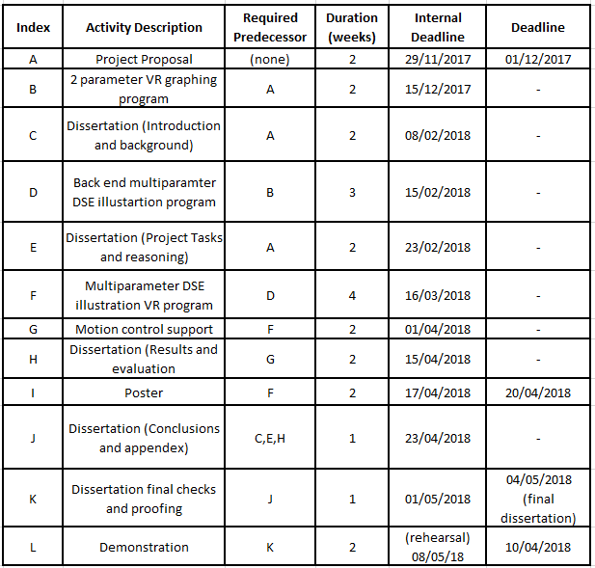

Note: Tasks start date is typically (Internal deadline – duration), but some flexibility might be allowed.

# Work Plan Explanation

The overall project plan relies on waterfall like development methods with clear steps to allow for a ridged structure and simple steps towards the goals of the project. However, some level of agility will be used allow for quick revisions based on supervisor feedback and to allow routine testing to be integrated with the tasks themselves to detect issues early.

The plan is divided into two main routes during most of the duration of the project, a project route and a dissertation route. The two routes later join before finalising the dissertation results and conclusions. The main critical path extends from the project proposal, the project tasks, the poster and finally the final demonstration.

The project tasks involve the creation of the initial two parameterised graphing/charting virtual reality tool for experimental prototyping, then the creation of the back end of the Design Space Exploration to communicate with the INTO-CPS toolset and finally the full program with the user controlled parameters and eventual motion control support. Dissertation tasks follow the basic structure of introduction, background, results and conclusions.

Progress so far has been limited to background research of sources specified in the background section of this document and some research into the INTO-CPS toolset. The basic background research carried for this document helps clarify the motivation, objectives and scope of the project before starting the prototyping stages. The research into the INTO-CPS tools included some experimentation with the toolset and mostly background reading on the toolset and some of the models created using it.

Potential risks in the plan include the threat of delays in the main critical path (project to demonstration), limited supplies of Virtual Reality hardware and the potential API/compatibility issues due to the recency of VR. To mitigate and work around these risks, various contingency plans have been considered. These plans include the use of generous internal deadlines (e.g. for the dissertation background and introduction), early appointments for the use of VR equipment in the Open Lab and the use of officially supported libraries like Unity.

# References

1. Gries, M., 2004. Methods for evaluating and covering the design space during early design development. *Integration, the VLSI Journal*, 38(2), pp.131–183.
2. Al-Hammouri, A.T., 2012. A comprehensive co-simulation platform for cyber-physical systems. *Computer Communications*, 36(1), pp.8–19.
3. Kokhazadeh, A. & Fatemi, O., 2011. Design space pruning of MPSoCs using weighted sub-sampling. *Electronics, Circuits and Systems (ICECS), 2011 18th IEEE International Conference on*, pp.550–553.
4. Valdés, Romero & Barton, 2012. Data and knowledge visualization with virtual reality spaces, neural networks and rough sets: Application to cancer and geophysical prospecting data. *Expert Systems With Applications*, 39(18), pp.13193–13201.
5. Fitzgerald, J., Gamble, C., Payne, R., Pierce, K. (2016) Method Guidelines 2. D3.2a, INTO-CPS project (644047).
6. Lausdahl, K., Larsen, P. G., Wolf, S., Bandur, V., Terkelsen, A., Hasanagić, M., Hansen, C. T., Pierce, K., Kotte, O., Pop, A., Brosse, E., Brauer, J., Möller, O. (2015) Design of the INTO-CPS Platform. D4.1d, INTO-CPS project (644047).
7. Velev, D. & Zlateva, P., 2017. Virtual Reality Challenges in Education and Training. *International Journal of Learning and Teaching*, pp.33–37.